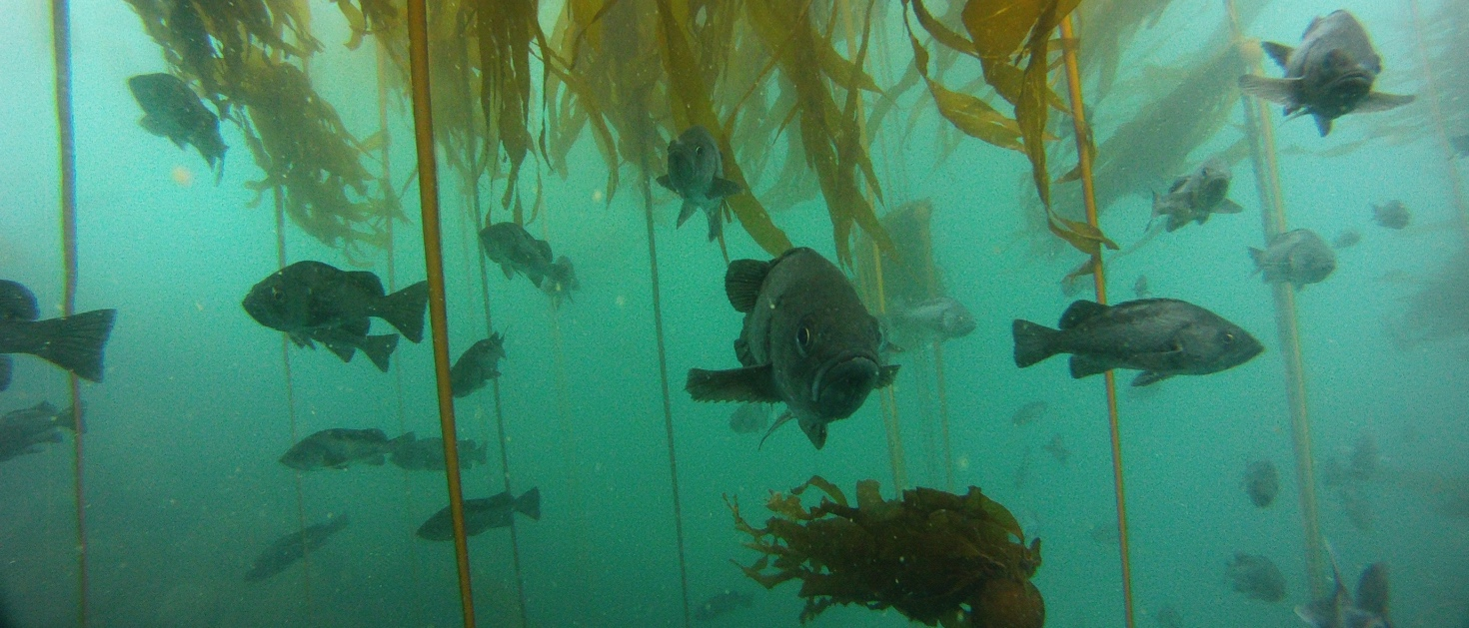
WHAT WE ASKED
SUMMARY OF RECENT SCIENTIFIC PUBLICATION
BASED ON FIELD RESEARCH IN HAIDA GWAII & GWAII HAANAS

Article title: The paradox of inverted biomass pyramids in kelp forest fish communities

Authors: Rowan Trebilco, Nick Dulvy, Sean Anderson, Anne Salomon
Publication: Proceedings of the Royal Society of London B (22 July 2016 issue)

Thanks to the Gwaii Haanas Archipelago Management Board, the Council of the Haida Nation, Parks Canada and Fisheries and Oceans Canada for supporting this research.

What determines the number and size of fishes found on reefs? Are their biomass pyramids bottom-heavy, with more small fishes than large ones? Or are they inverted, with more large fishes than small? Why?
We shed new light on these questions by combining data from dive surveys of the fish on reefs surrounding Louise, Lyell and Kunghit Islands of Haida Gwaii, British Columbia between 2009 and 2012, with analysis of stable isotopes the fishes' muscle tissue. Stable isotopes are chemical tracers that can tell us the trophic position of individual fish - or how many 'steps' they are above the base of the foodchain. By looking at the trophic position of many individual fish, we built a picture of the overall relationship between trophic position and body size. We then took this information and used it to ask what shape of biomass pyramids would be expected, based on a theoretical model of how biomass and energy move up the food chain from smaller predators to larger prey. We compared this with what we actually observed in dive surveys to ask what it tells us about how energy enters and moves through reef fish communities.

WHAT WE FOUND
In our dive surveys, we observed that biomass pyramids were inverted, with more biomass of fishes at larger body sizes than at smaller sizes. The stable isotope data also showed us that there was a strong positive relationship between trophic level and body size – which is what you’d expect given that fish are gape limited predators that swallow their prey whole. But, where it gets interesting is that inverted biomass pyramids are the opposite of what you’d expect based on theory. If there’s a positive relationship between trophic level and body size, pyramids should be bottom heavy. That is, if fish on reefs are “closed communities” – where all the energy comes from the same source. This tells us that reefs must be “energetically open” and a lot of the biomass in large fish comes from broader scales than the local reef. In this case, this case there was 4-5x more biomass in the largest size-class (1-2kg) than you’d expect for a closed community.

WHY IT MATTERS
Our results suggest that:
- Reef ecologists need to consider that reef fish aren’t closed communities when trying to understand what drives community structure
- If reefs are “energetically open”, this implies that energy flow and ecosystem function take place at much broader spatial scales than the local reefs themselves. Conservation and management strategies that only focus at the local scale are therefore likely to run into problems. This lends further support to arguments that management and conservation should expand in scale and scope towards a seascape and ecosystem approach.

